# Servlet Interface->

**Servlet interface** provides common behaviour to all the servlets.

Servlet interface needs to be implemented for creating any servlet (either directly or indirectly). It provides 3 life cycle methods that are used to initialize the servlet, to service the requests, and to destroy the servlet and 2 non-life cycle methods.

# 

GENERIC SERVLET->

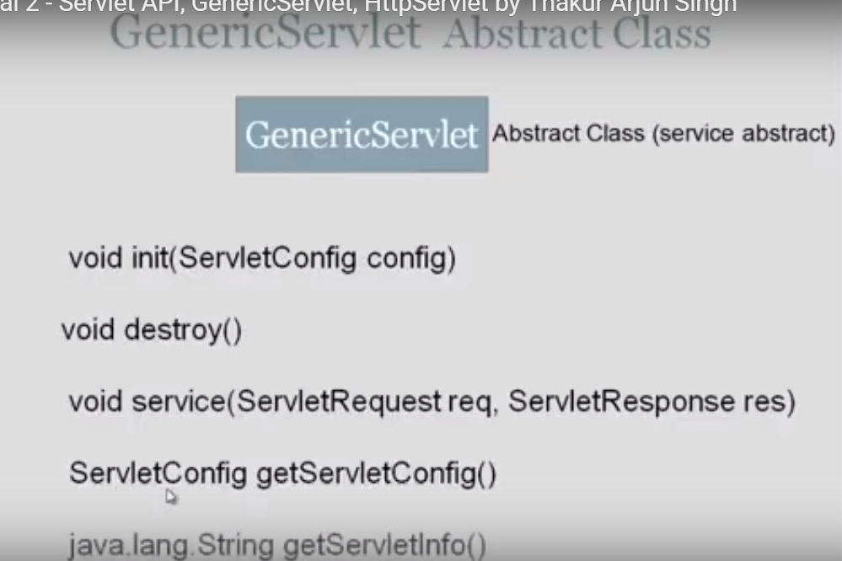

HTTPS SERVLET->

